Your Life Compass

Name ________________________________________ Date ___________________________

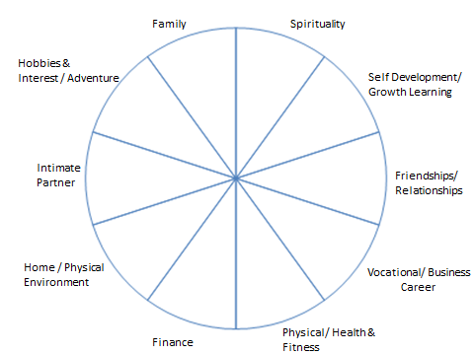

Your Life Compass instructions:
- The 10 sections in the life compass represent balance.
- Please change, split or rename any category so that it’s meaningful and represents a balanced life for you.
- Next, taking the centre of the compass as 0 and the outer edge as 10, rank your level of satisfaction with each area out of 10 by drawing a straight or curved line to create a new outer edge.
- Now develop goals for each of the categories. Write positive can do statements. Eg By December 2010 I will be participating in the local tennis tournaments on a regular basis (monthly).

Category | Goal | Achieve by
Spirituality
Self Development/ Growth Learning
Friendships/ Relationships
Vocational / Business Career
Physical / Health and Fitness
Finance
Home/ Phyical Environment
Intimate Partner
Hobbies & Interests / Adventure
Family

