Five Principles for Success

 | - Know your outcome  - People spend more time planning their holidays than their life.  - What do you want day to day to experience?  - What do you want to achieve?  - People can get caught up in the process and forget why they are doing it.
 | - Take action.  - Just say “Yes” and work out the how later.  - In any situation, the best thing you can do is the right thing; the next best thing you can do is the wrong thing; the worst thing you can do is nothing.  - You miss 100% of the shots you don’t take.  - If you don't make things happen then things will happen to you.
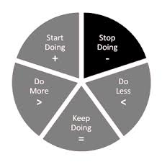 | - Have sensory acuity to notice what’s working and what’s not working.  - Is what you are doing effective?  - Doing the same thing over and over again yet there is no change to the outcome is madness.  - If it does not work try something different.  - By changing nothing, nothing changes.
 | - Have behavioural flexibility to make changes as required.  - Do you need to change you, your goal or how you get there?  - Your life does not get better by chance, it gets better by change.  - If today were the last day of my life, would I want to do what I am about to do today?”
 | - Operate from a physiology and psychology of excellence.  - Be aware of your body language- Stand tall, be confident, empowering, and certain.  - We are what we repeatedly do. Excellence, then, is not an act, but a habit.  - If you are content with the best you have done, you will never become the best you can be

